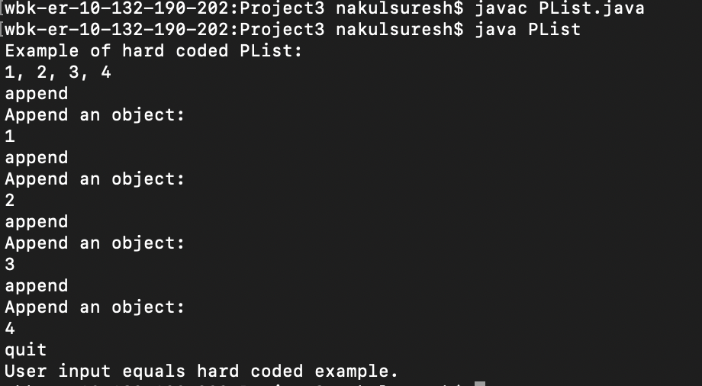

Strings “1”, “2”, ”3”, ”4” were hard-coded by using the append function. Thereafter, I appended those same strings using the user interface. In my code, I wrote if they are equal print “User input equals hard coded example.” As a result, my equals method worked. Furthermore, since “1, 2, 3, 4” printed nicely, this also shows that my toString method was implemented correctly.

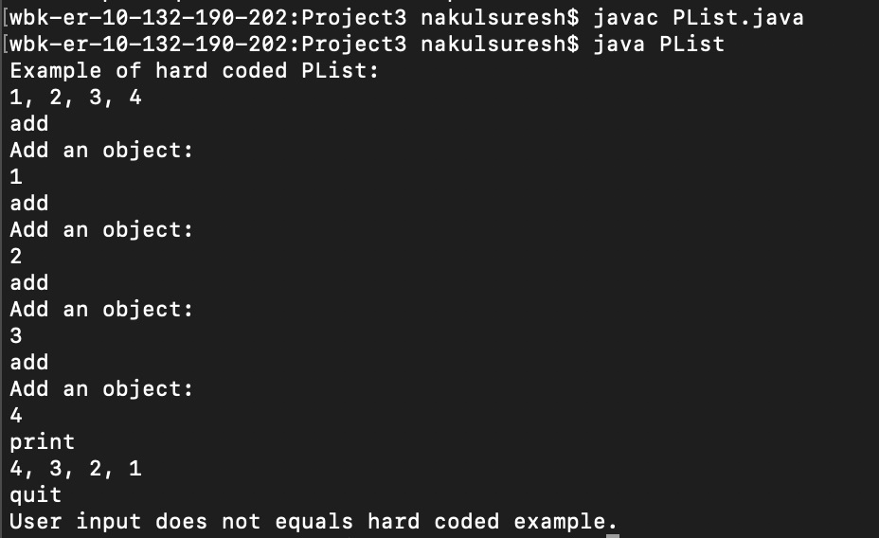

This time I used the user interface to ‘add’ elements to my PList. Since it is different than the hard-coded example, “User input does not equal hard coded example is printed.”

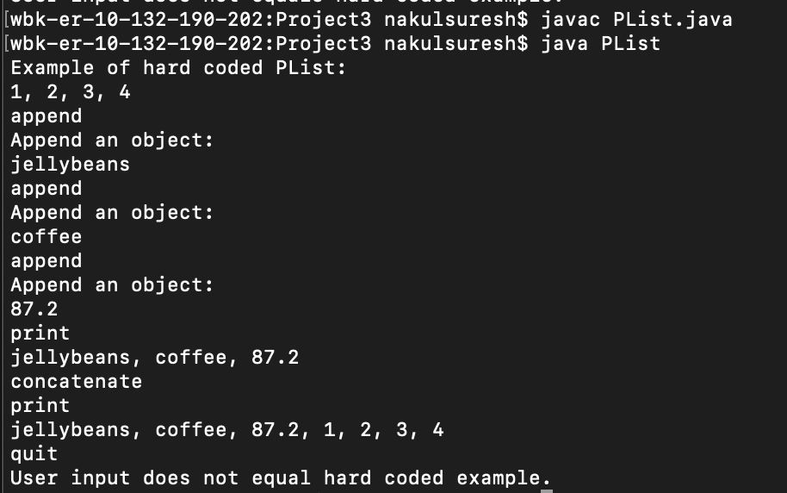

I made a PList of random things {“jellybeans”, “coffee”, “87.2}. The ‘concatenate’ command concatenates the hard-coded PList to the PList made by the user.

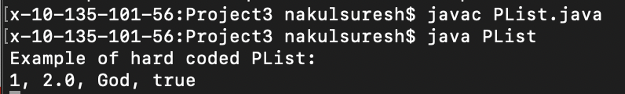

Here is an example of adding different types of objects to the PList. The PList appends these various types of objects, but in the ‘append’ method it converts the objects to Strings. You can find this hard-coded version in my main method.

Complexity Analysis:

1. Add

O(1) because each operation is done once.

1. Append

O(n) because the run time depends on the number of nodes in ‘temp.’

1. Concatenate

O(n) because the run time depends on the number of nodes in ‘plist.’

1. Delete

O(n) because the run time depends on the position of the index; the loop may have to iterate many times to find the correct index.

1. Get

O(n) because the run time depends on the position of the index; the loop may have to iterate many times to find the correct index.

1. Length

O(n) because we need to count the number of nodes in the linked list, which can vary depending on the number of objects we add.

1. Print

O(n) because we need to iterate through the entire length of the linked list to print each data.

1. Insert

O(n) because the run time depends on the position of the index; the loop may have to iterate many times to find the correct index.

1. Remove

O(n) because the run time depends on the position of the item; the loop may have to iterate many times to find the correct item.

1. Sort

O(n2) because a nested for loop is used to compare values in the linked list.

1. Create

O(1) because the operation is executed once.